Name:- Ranit Pradhan

Experiment No: 6 Date: 12th Apr 2021

**Fourier Representations**

**AIM:**

To find the fourier representations of continuous time and discrete time signals

**Lab Exercise:**

1. Write a matlab program to compute the fourier series coefficients of the given signals.
2. $cos⁡(πn/4)$ (T=8) b. $sin⁡(πn/8)$ c. $x\left[n\right]=1+\sin\left(\frac{πn}{12}\right)+\frac{3π}{8}$ (T=24)

a)

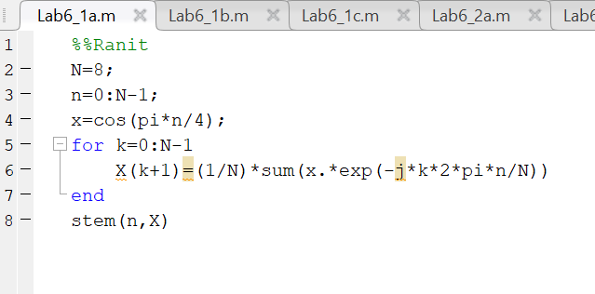

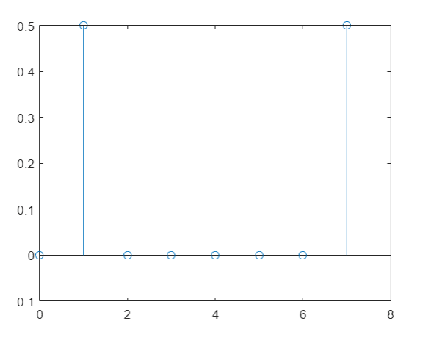

b)

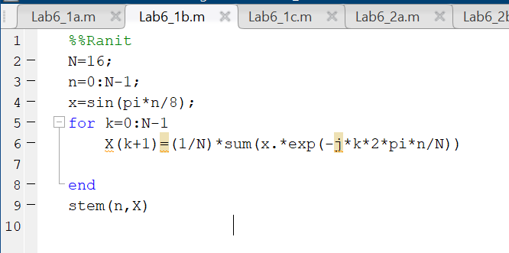

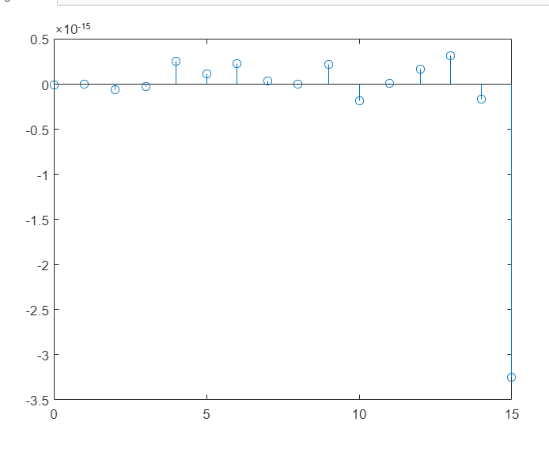

c)

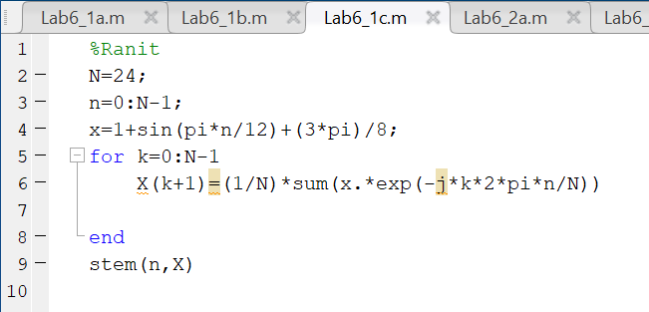

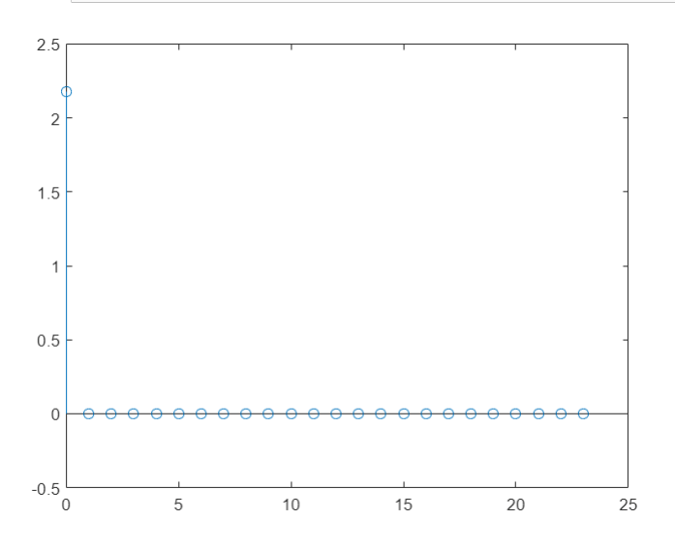

1. Use Matlab to find the fourier transform of the following
2. $x\left(t\right)=te^{-3t}u(t)$ b. $x\left(t\right)=e^{2t}u(-t)$

a)

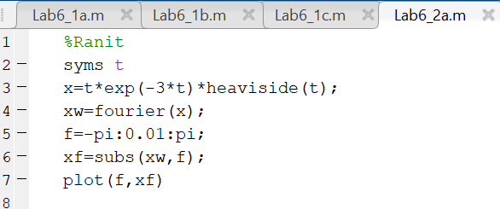

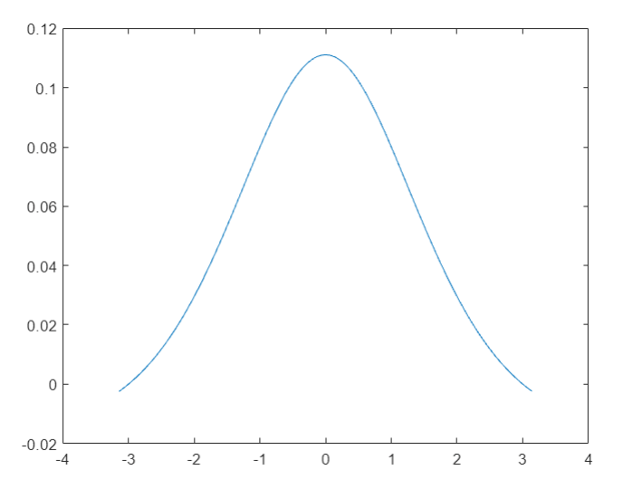

b)

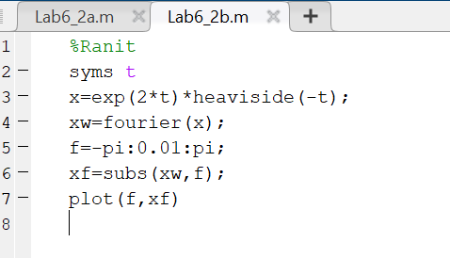

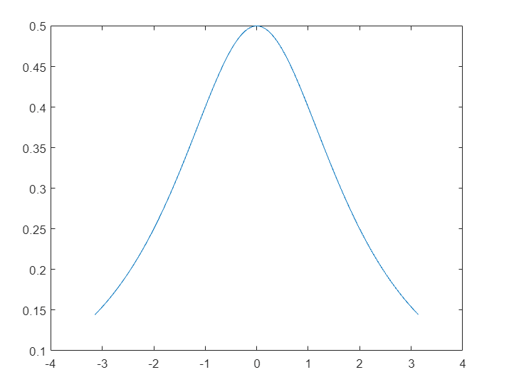

1. Plot the natural response (first 20 points) of the discrete system y(n) + 1.12y(n-1) = 0.1x(n) + 0.2x(n-1) with initial condition y(-1) = 1.

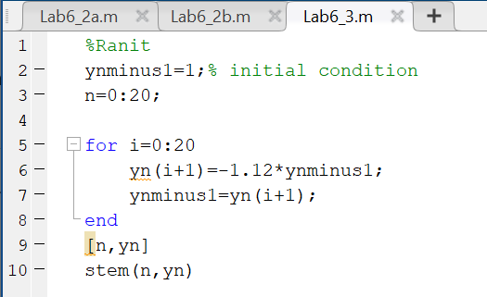

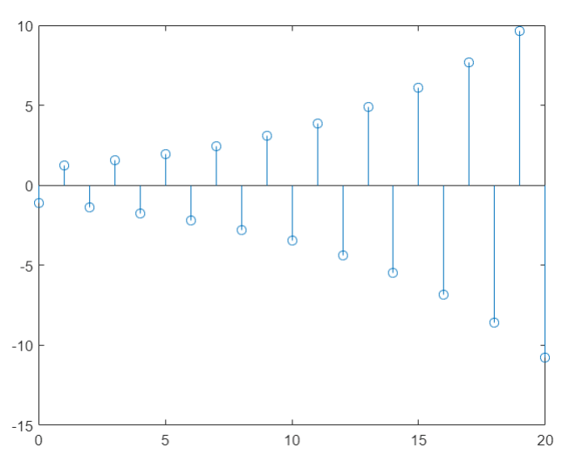

1. Write a MATLAB program to solve the difference equation $y\left[n\right]-2.2y\left[n-1\right]+1.57y\left[n-2\right]-0.36y\left[n-3\right]=x\left[n\right] for 0≤n≤50$, Where x[n] = u[n] and y[-1]=y[-2]=y[-3] = 0.

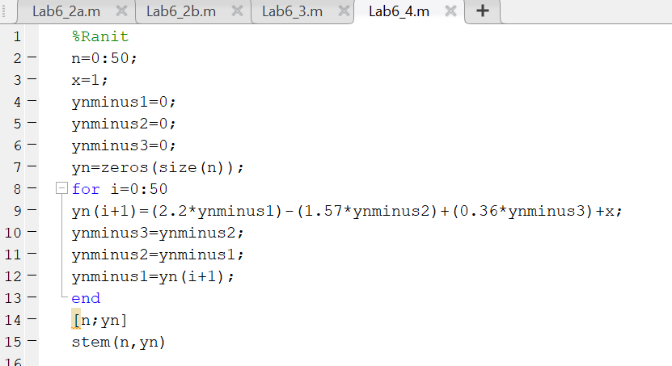

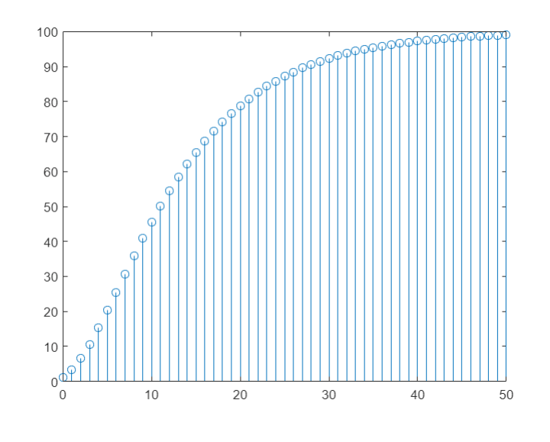

1. Find the frequency response of the MEMS accelerometer system and plot the magnitude response (dB). Given Q=200 and ωn=10,000 rad/s.



w=1:100:100000;

b=1;

a=[1 50 10000*10000];

H=freqs(b,a,w);

plot(w,20*log10(abs(H)));



